**YEAR 11 FRENCH LEARN SHEETS**

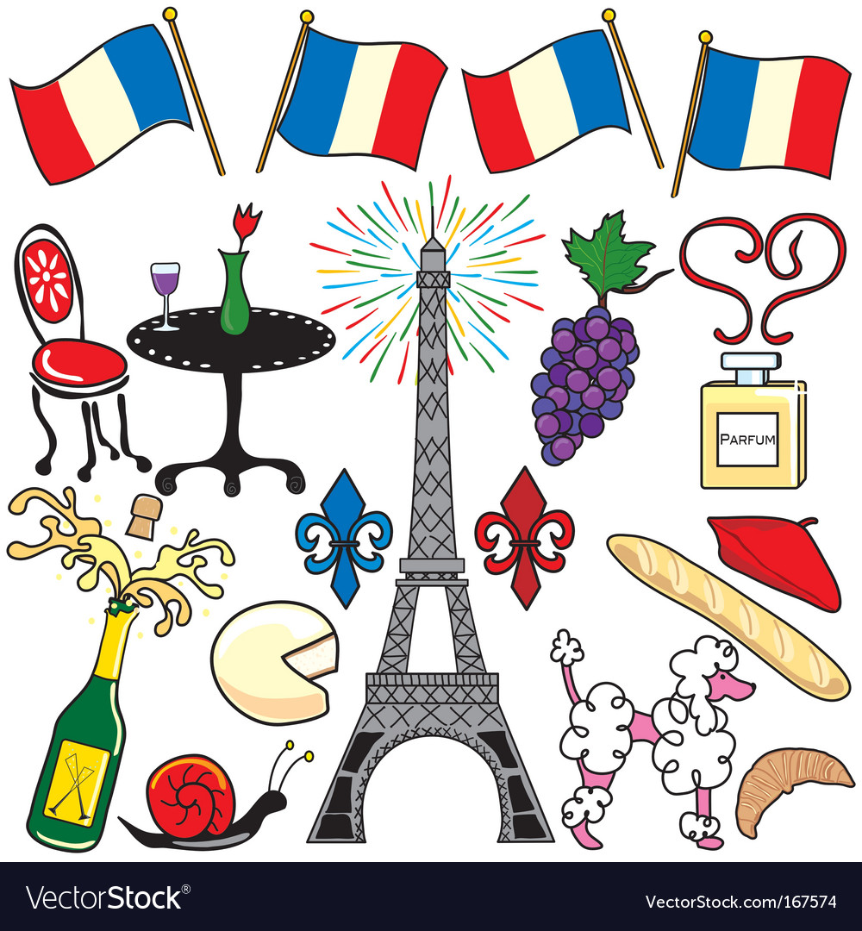

**2023-2024**

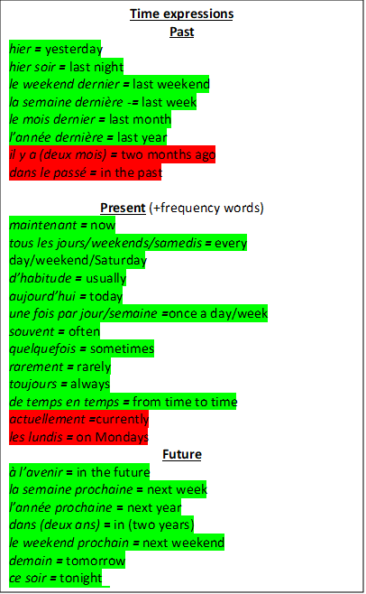

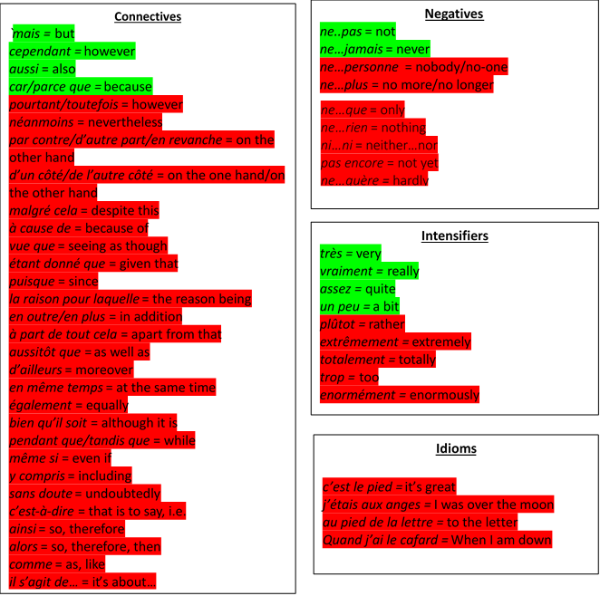

High Frequency Phrases

**Comparative**

more than *plus … que*

*e.g. l’histoire est plus difficile que l’anglais =*

*History is more difficult than English*

less than *moins … que*

*e.g. il est moins intelligent que moi = he is less intelligent than me*

as … as *aussi … que*

*e.g. il est aussi gentil que moi = he is as kind as me*

good *bon* better *meilleur*

bad *mauvais* worse *pire*

**Superlative**

le plus beau …… *the most beautiful …*

la plus **belle** … (fem) *the most beautiful…*

le plus intelligent *the most intelligent*

la plus intelligent**e** *the most intelligent (fem)*

le moins fatigant *the least tiring*

le/la/les meilleur(e)(s) = the best

le/la/les pire(s) = the worst

**Adjectives**

*passionnant* = exciting

*incroyable* = incredible

*formidable* = fantastic

*rigolo/marrant/drôle* = funny

*amusant =* fun

chouette/génial = *great*

*barbant/ennueyux =* boring

*sensass* - sensational

*divertissant* = entertaining

*merveilleux* = marvellous

*captivant* = captivating

*désagréable* = unpleasant

*affreux* = awful

*inutile* = useless

*fatigant* = tiring

*dégoûtant* = disgusting

*agaçant* = annoying

*monotone =* monotonous

*gratifiant =* rewarding

*satisfaisant =* satisfying

*irritant =* irritating

**Possessive adjectives**

**Gender = dependent on the noun following it, rather than the person the noun belongs to!**

My e.g. mon père = my dad

|  |  |  |
| --- | --- | --- |
| Masculine | Feminine | Plural |
| mon | ma | mes |

Your (tu) e.g. ta sœur = your sister

|  |  |  |
| --- | --- | --- |
| Masculine | Feminine | Plural |
| Ton | ta | tes |

his/her e.g. ses amis = his/her friends

|  |  |  |
| --- | --- | --- |
| Masculine | Feminine | Plural |
| son | sa | ses |

Your (vous) e.g. votre chat = your cat

|  |  |  |
| --- | --- | --- |
| Masculine | Feminine | Plural |
| votre | votre | vos |

Our (nous) e.g. nos parents = our parents

|  |  |  |
| --- | --- | --- |
| Masculine | Feminine | Plural |
| notre | notre | nos |

**Question words**

*qui =* who

*quand =* when

*comment =* how

*quel/quelle/quels/quelles* = which

*que* = what

*combien (de) =* how much/many

*où =* where

*pourquoi =* why

*à quelle heure* = at what time

**Opinion phrases**

*`je pense que =* I think that

*à mon avis* = in my opinion

*je crois que =* I believe that

*je dirais que =* I would say that

*selon moi =* according to me

*je trouve ça* = I find it

*il me semble que* = it seems to me that

*en ce qui me concerne* = according to me

*personnellement* = personally

*je suis d’accord/je ne suis pas d’accord* = I agree/disagree

*je dois admettre que/je tiens à dire que* = I have to say that

*je considère que/j’estime que* = I think that

*j’ai horreur de…*= I hate

*j’ai une passion pour…*= I have a passion for…

*je suis pour/contre* = I am for/against

*ce que j’aime c’est* = what I like is

*je suis d’avis que =* I am of the opinion that

*j’espère que =* I hope that





