YEAR 11 FRENCH LEARN SHEETS
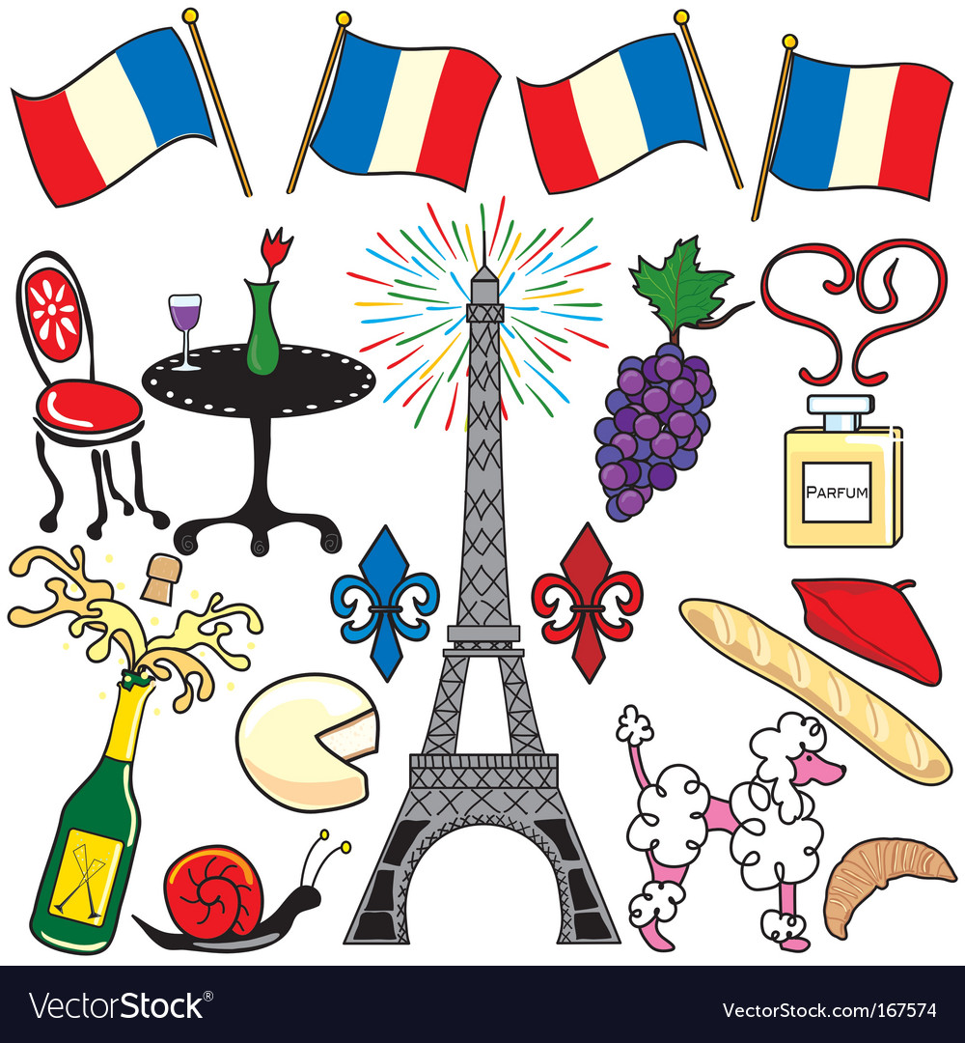

2023-2024

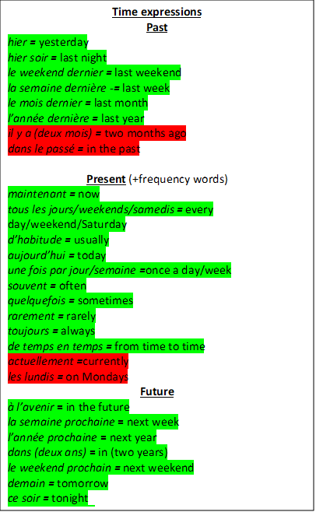
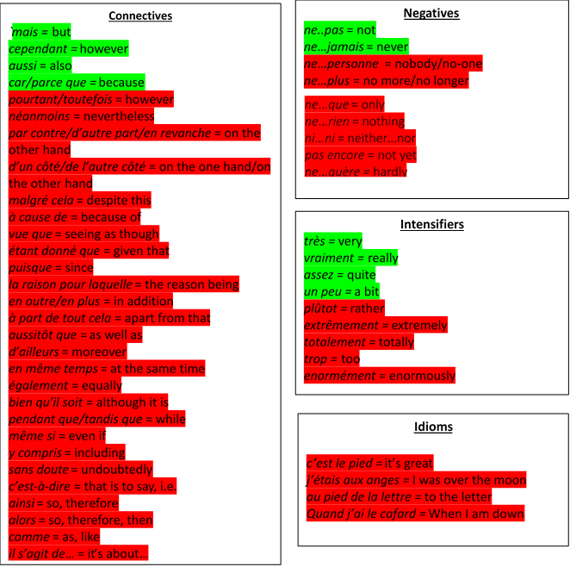
High Frequency Phrases

Comparative
more than plus … que
e.g. l’histoire est plus difficile que l’anglais =
History is more difficult than English

less than moins … que
e.g. il est moins intelligent que moi = he is less intelligent than me

as … as aussi … que
e.g. il est aussi gentil que moi = he is as kind as me

good bon better meilleur
bad mauvais worse pire
Superlative
le plus beau …… the most beautiful …
la plus belle … (fem) the most beautiful…
le plus intelligent the most intelligent
la plus intelligente the most intelligent (fem)
le moins fatigant the least tiring
le/la/les meilleur(e)(s) = the best
le/la/les pire(s) = the worst

Adjectives
passionnant = exciting
incroyable = incredible
formidable = fantastic
rigolo/marrant/drôle = funny
amusant = fun
chouette/génial = great
barbant/ennueyux = boring
sensass - sensational
divertissant = entertaining
merveilleux = marvellous
captivant = captivating
désagréable = unpleasant
affreux = awful
inutile = useless
fatigant = tiring
dégoûtant = disgusting
agaçant = annoying
monotone = monotonous
gratifiant = rewarding
satisfaisant = satisfying
irritant = irritating

Possessive adjectives
Gender = dependent on the noun following it, rather than the person the noun belongs to!
My e.g. mon père = my dad
Masculine | Feminine | Plural
mon | ma | mes
Your (tu) e.g. ta sœur = your sister
Masculine | Feminine | Plural
Ton | ta | tes
his/her e.g. ses amis = his/her friends
Masculine | Feminine | Plural
son | sa | ses
Your (vous) e.g. votre chat = your cat
Masculine | Feminine | Plural
votre | votre | vos
Our (nous) e.g. nos parents = our parents
Masculine | Feminine | Plural
notre | notre | nos

Question words

qui = who
quand = when
comment = how
quel/quelle/quels/quelles = which
que = what
combien (de) = how much/many
où = where
pourquoi = why
à quelle heure = at what time

Opinion phrases
`je pense que = I think that
à mon avis = in my opinion
je crois que = I believe that
je dirais que = I would say that
selon moi = according to me
je trouve ça = I find it
il me semble que = it seems to me that
en ce qui me concerne = according to me
personnellement = personally
je suis d’accord/je ne suis pas d’accord = I agree/disagree
je dois admettre que/je tiens à dire que = I have to say that
je considère que/j’estime que = I think that
j’ai horreur de…= I hate
j’ai une passion pour…= I have a passion for…
je suis pour/contre = I am for/against
ce que j’aime c’est = what I like is
je suis d’avis que = I am of the opinion that
j’espère que = I hope that

