******Year 7 French DC1 Learn Sheet – Key French Vocabulary**

Les animaux - Animals

un chien – a dog

un chat – a cat

un lapin – a rabbit

un cheval – a horse

une tortue – a turtle

un cochon d’Inde – a guinea pig

un serpent – a snake

je n’ai pas d’animal – I don’t have a pet

Les couleurs – Colours

rouge – red

noir – black

blanc - white

jaune – yellow

violet – purple

orange – orange

rose – pink

vert - green

bleu – blue

gris – grey

marron - brown

*Describing hair or eyes? Add an -s at the end!*

Les salutations – Greetings

Salut – Hi

Bonjour – Good day

Au revoir - Goodbye

Ma personnalité – My personality

Je (ne) suis (pas) – I am (not)

Gentil(le) - kind

Intelligent(e) - intelligent

poli(e) - polite

amusant(e) - funny

branché(e) - trendy

sympa – nice

généreux(se) - generous

Tout sur moi – All about me

Je m’appelle – My name is

Je suis – I am

J’ai (onze) ans – I am (11) years old

J’habite à – I live in

Mon anniversaire, c’est le (trois décembre) – My birthday is the 3rd of December

Mon apparence – My appearance

J’ai les yeux bleus – I have blue eyes

J’ai les cheveux blonds, frisés et longs – I have blonde, curly, long hair

Je suis grand(e) - I am tall

Je ne suis pas mince – I am not slim

Je (ne) porte (pas) des lunettes – I (don’t) wear glasses

Les mois – Months

janvier – January

février – February

mars – March

avril – April

mai – May

juin – June

juillet – July

septembre – September

octobre – October

novembre – November

décembre - December

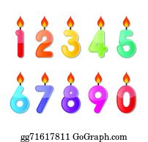****

Les numéros – Numbers

1 – un 2 – deux 3 – trois

4 – quatre 5 – cinq 6 – six

7 – sept 8 – huit 9 – neuf

10 – dix 11 – onze 12 – douze

13 – treize 14 – quatorze

15 – quinze 16 – seize

17 – dix-sept 18 – dix-huit

19 – dix-neuf 20 – vingt

21 – vingt-et-un 22 – vingt-deux

23 – vingt-trois 24 – vingt-quatre

25 – vingt-cinq 26 – vingt-six

27 – vingt-sept 28 – vingt-huit

Les numéros – Numbers

29 - vingt-neuf

30 – trente

40 – quarante

50 – cinquante

60 – soixante

70 – soixante-dix

80 – quatre-vingt

90 – quatre-vingt-dix

100 - cent

La famille – Family

Dans ma famille, il y a – In my family there is

Ma mère/Ma belle-mère – My mum / stepmum

Mon père/Mon beau-père – My dad / stepdad

Mon frère/Ma soeur - My brother /sister

Ma demi-soeur/Mon demi-frère

- My stepbrother / stepsister

Mon oncle/Ma tante – My uncle / my aunt

Mon grand-père/Ma grand-mère – my grandad/ grandma

Mon cousin/Ma cousine - my cousin



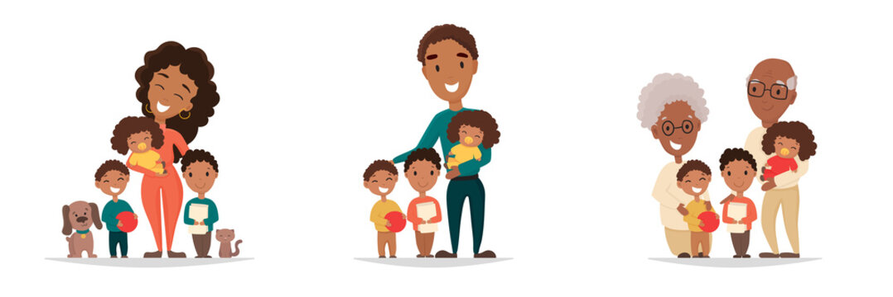**Year 7 French DC1 Learn Sheet - French Grammar**

Key questions

ça va? – How are you?

Comment t’appelles-tu? –

What’s your name?

Où habites-tu? –

Where do you live?

Quel âge as-tu? –

How old are you?

Quelle est la date de ton anniversaire? –

When is your birthday?

Décris ta famille.

Describe your family.

Negatives in French

In French to make a verb negative, you just need to add “ne” and “pas” around the verb.

Je suis – I am

Je **ne** suis **pas** – I am not

Intensifiers

assez – quite

très – very

un peu – a little

vraiment – really



Key 3rd Person verbs

Il / Elle est – He / She is

Il / Elle s’appelle – He / She is called

Il / Elle a – he / She has

Il / Elle a (douze) ans – He / She is (35) years old

Connectives

mais – but

et – and

ou – or

cependant – however

aussi - also

Top tips for perfect French grammar

1. Make sure any adjectives come after the noun they are describing. (For example: J’ai **un chien blanc** – I have a white dog)
2. Make sure you use “**j’ai**” when describing your age. Remember in French we do not say how many years old we are, we say how many years we have. (For example: **J’ai douze ans** – I am 12 years old)
3. Make sure when you use adjectives to describe people, the ending of the word agrees with the gender of who it is describing. (For example: **Mon frère est amusant et ma soeur est gentille** – My brother is fun and my sister is kind)
4. To talk about more than one of something (two dogs, three sisters etc.) you must add an “s” to the end of the word. (For example: **Dans ma famille, il y a mes deux soeurs et trois chats** – In my family there are my two sisters and three cats)
5. Make sure when you are describing your eye colour, the colour is spelt correctly. As the word for eyes is plural “**les yeux**”, the colour must also be plural, apart from **marron** (brown), that never changes its spelling. (For example: **J’ai les yeux bleus** – I have blue eyes).