What is latitude and longitude?
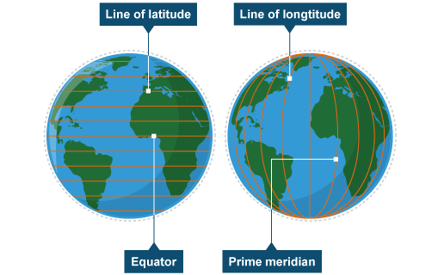
The Equator is an imaginary line around the middle of the Earth. It is halfway between the North and South Poles, and divides the Earth into the Northern and Southern Hemispheres.
Lines of latitude measure how far north or south from the equator a place is.
Longitude is a measurement of location east or west of the prime meridian at Greenwich, the specially designated imaginary north-south line that passes through both geographic poles and Greenwich, London

The most important lines of latitude are shown on the diagram below:
