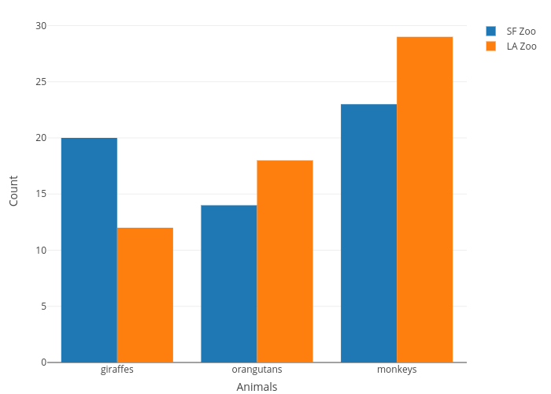
Bar Chart
Type of graph plotted for one piece of categoric data and one piece of continuous data
Transition / Scientific Skills Knowledge Organiser
Types of Variable
Independent – the variable that is changed
Dependent – the variable that is measured
Control – the variable that stays the same
Types of Data
Categoric – values that are labels e.g. type of plant
Continuous – values that are numbers e.g. temperature
Line Graph
Type of graph plotted for two pieces of continuous data
Has a line of best fit. This may be a straight line or a curve (not join the dots)
Accurate – close to the true value Key Words
Anomalous – a result that doesn’t fit the pattern
Precise – small amount of spread around the mean
Reproducible – if the same results are obtained by different people for the same investigation
Range – the biggest and smallest values of the independent or dependent variable e.g. 0-10 N
Volume – amount of a liquid
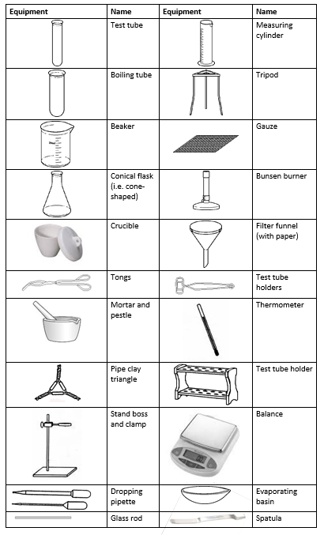
Tables
Units only go in headings
Time (s) | Vol. gas (cm³)

Independent Variable (unit)
Dependent Variable (unit)

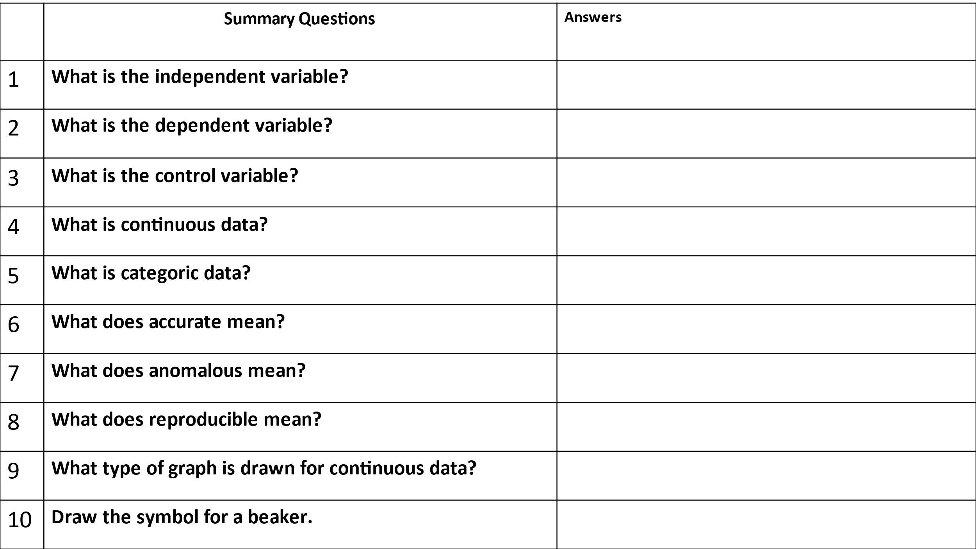
Scientific Skills Knowledge

